- Define Bank Account Class
Create a class named BankAccount.
The class should have private fields for:
id: int
balance: double
The class should also have public properties for:
ID: int
Balance: double
You should be able to use the class like this:
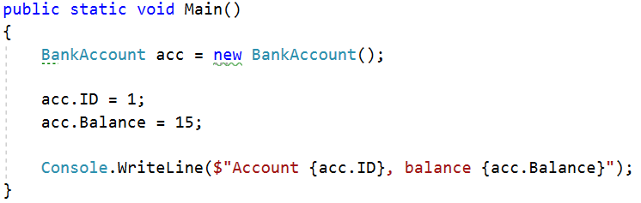
Solution
Create a new class and ensure proper naming
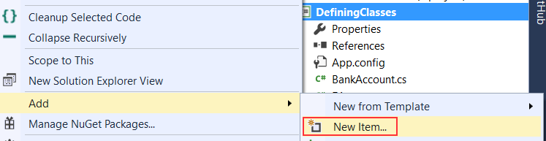
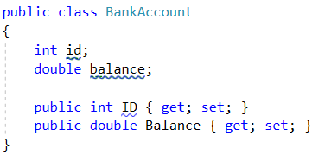

- Methods
Create a class BankAccount (you can use class from previous task)
The class should have private fields for:
id: int
balance: double
The class should also have properties for:
ID: int
Balance: double
Deposit(Double amount): void
Withdraw(Double amount): void
Override the method ToString().
You should be able to use the class like this:
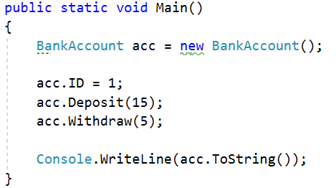
Solution
Create a method Deposit(double amount)
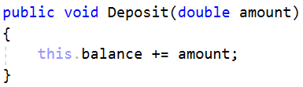
Create a method Withdraw(double amount)
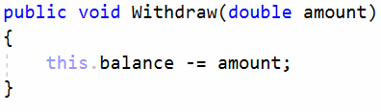
Override the method toString()
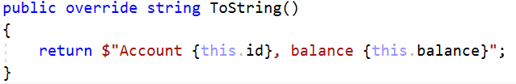

- Test Client
Create a test client that tests your BankAccount class.
Support the following commands:
Create {Id}
Deposit {Id} {Amount}
Withdraw {Id} {Amount}
Print {Id}
End
If you try to create an account with existing Id, print "Account already exists".
If you try to perform an operation on non-existing account with existing Id, print "Account does not exist".
If you try to withdraw an amount larger than the balance, print "Insufficient balance".
The Print command should print "Account ID{id}, balance {balance}". Round the balance to the second digit after the decimal separator.
Examples
Input | Output
Create 1  Create 1  Deposit 1 20  Withdraw 1 30  Withdraw 1 10  Print 1  End | Account already exists  Insufficient balance  Account ID1, balance 10.00
Create 1  Deposit 2 20  Withdraw 2 30  Print 2  End | Account does not exist  Account does not exist  Account does not exist
Solution
Create a Dictionary<int, BankAccount> to store existing accounts
Create the input loop
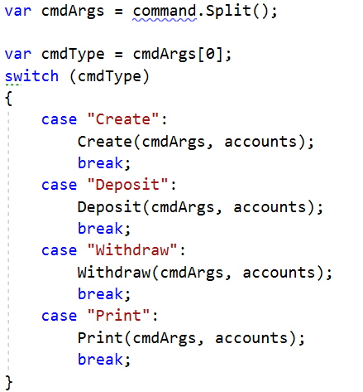
Check the type of command and execute accordingly (optional: you can create a separate method for each command)
Implement the Create command
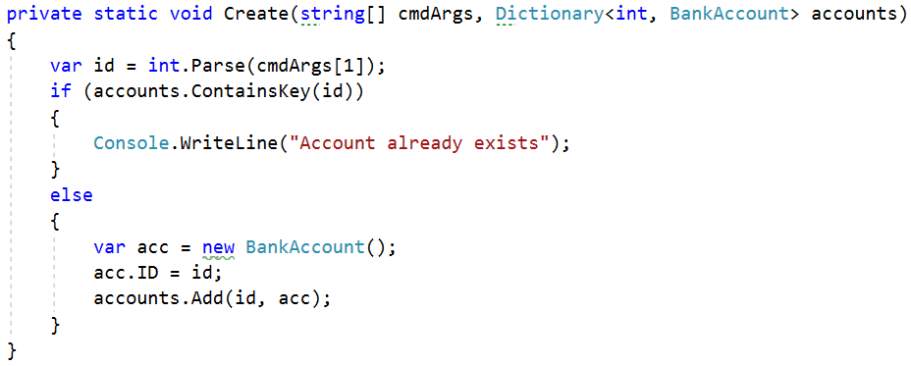
Implement the rest of the commands following the same logic

- Define Person Class
Create a Person class.
The class should have private fields for:
Name: string
Age: int
Accounts: List<BankAccount>
The class should have constructors:
Person(string name, int age)
Person(string name, int age, List<BankAccount> accounts)
The class should also have public methods for:
GetBalance(): double
Solution
Create the class as usual
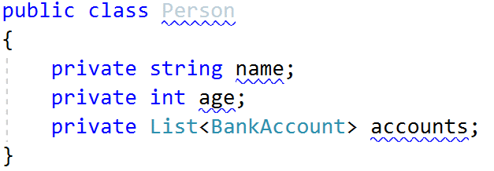
Create a constructor with two parameters
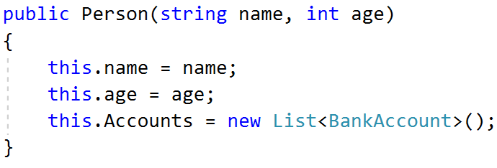
Create a constructor with three parameters
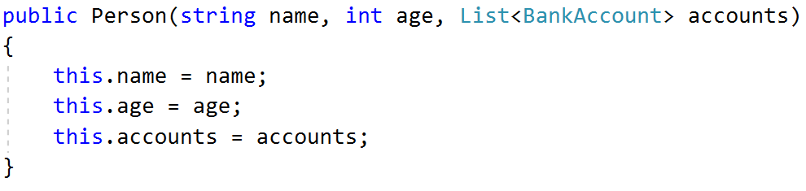
Create method GetBalance()
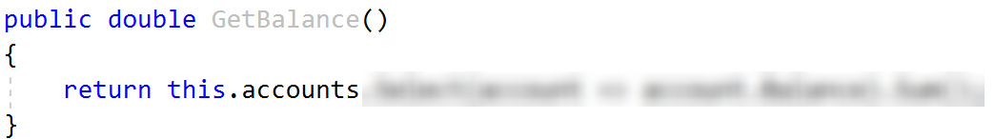
Optional: You can take advantage of constructor chaining
